Nokota Horse Conservancy® Registration, Foal Report, Change of Name, Change of Color, or Reissuance of Papers Request Forms:

Request Type:
___ Registration Request ($50 + foal report)
___ Foal Report ($10 first year; $25 subsequent years)
___ Change of name ($20 fee)
___ Change of Color ($5 fee)
___Reissue Papers ($20 fee)

Foal Reports and Registration Requests fill out the following:
Name of horse:
Sire:
Dam:
Date/year foaled:
Gender:
Physical description, including color, number and location of swirls, any white or lamination of hooves, and markings:
Please include pictures of the horse from each side, showing all four legs, as well as a picture of the face from directly in front. The picture of the face should show the entire face, including the muzzle and needs to have the forelock pulled out of the way so that the swirls show.

Examples of appropriate photos:
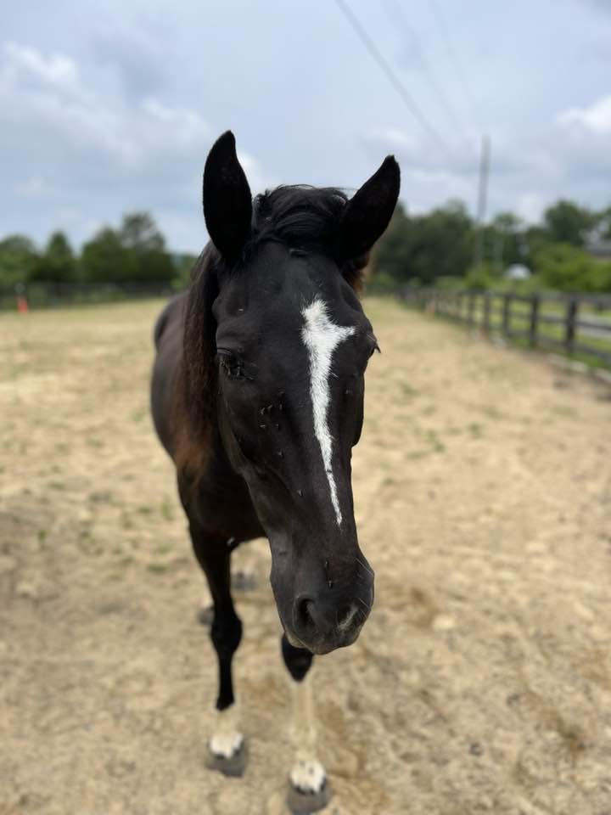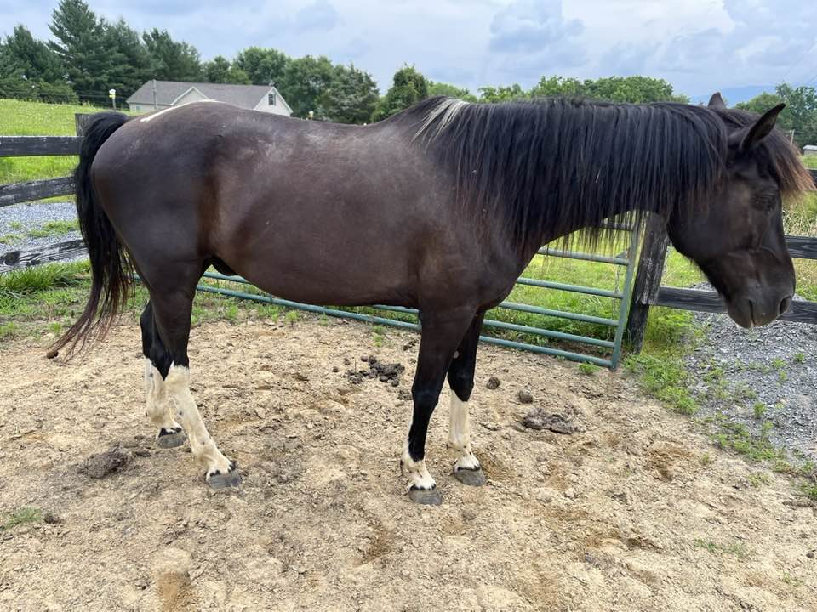
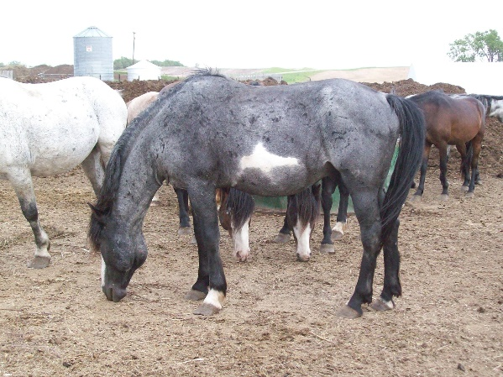
Breeder name:
Owner name and address:
Proof of ownership: please provide either a bill of sale or a signed registration paper. If the horse has a brand you also need a brand release.
Email this document to Nokota.Registry@gmail.com (the capitalization is important)

Payment: Please log on to www.nokotahorse.org and click on Register a Horse button to pay, or mail check to the Nokota Horse Conservancy ®, PO Box 761, Linton, ND 58552

Change of Name Request:
Registration Number: _____________________________
Original Name: __________________________________
New Name: _____________________________________

Change of Color Request:
Registration Number: _____________________
Horse’s name: _____________________________
Color listed on papers: ______________________
Revised color: _____________________________
There is a $5 fee for change of color, payable online at www.nokotahorse.org.

Reissuance of Papers Request:

Horse’s Registered Name: __________________________
Horse’s Parents (if known):
Sire: _____________________
Dam: _____________________
Owner Name: ____________________________________
Owner Address: ___________________________________
Note: only the owner of record can request reissued papers. There is a $20 fee payable online at www.nokotahorse.org.

