The Breed Registry
​
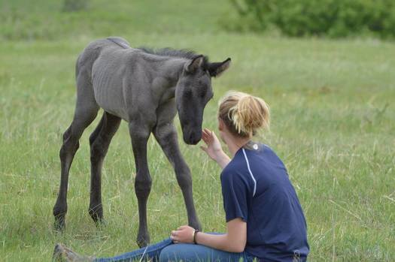
The Nokota® breed has been developed since 1986

The NHC has created a breed registry to support the conservation, breeding and individual ownership of Nokota® horses into the future. The registry currently tracks around two thousand horses, including both conservation breeding stock and those owned by close to three hundred and eighty private individuals. The registry database was developed by Charlie Fleischmann and is maintained by the NHC office in Linton, N.D. Shawna Lichtenwalner, registrar, welcomes comments and questions and may be contacted at Nokota.Registry@gmail.com
​
Registration is vital to the future of the Nokota® horses, and it becomes more important each year, as new foals arrive. By registering your horse and keeping us aware of births, deaths, and transfers, you make an important contribution towards establishing their security. Thank you for your help, and please don’t hesitate to contact us with questions. Nokotas® are a new breed and our policies continue to evolve. The NHC breed registration committee convenes at the annual June meeting and welcomes input from owners and breeders. Recent discussions have addressed how to restrict the re-sale of horses that are critical to the conservation effort, and how to encourage preservation breeders.
Initially the Kuntz family intended to cross-breed the park horses with their own ranch lines of Thoroughbreds, paints, ponies, and grade using horses. Later, two distinct breeding programs emerged: one aimed at preserving the original park strain, and a second, more commercial operation aimed at producing superior performance horses and ponies based on careful, limited outcrossing.
The basic categories of registration reflect these complementary goals. We seek to preserve and promote the family lines and phenotypes of the “original” Nokotas® removed from Theodore Roosevelt National Park while also recognizing the offspring of Nokotas® bred to non-Nokotas®. The Nokota Horse Conservancy® is concerned soley with preservation breeding for the original type.
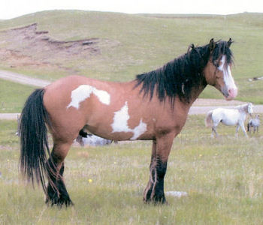
Grandpa Smoke is a perfect example of the Ranch Nokota®. He is also a stunning example of the tiger dun overo coloration. Photo by Shelly Hauge, summer of 2000.

REGISTRATION CATEGORIES
- ​Foundation Nokotas® were removed directly from the park, primarily during the 1980s and early 1990s. Many of the foundation stallions and mares, which formed the nucleus of the breed, are now deceased. Their offspring are termed “Foundation-bred” Nokotas®.
- On the advice of Dr. Phillip Sponenberg, the Foundation and Foundation-bred horses have been differentiated into two phenotypic categories, National Park Traditionals and National Park Ranch types (See “Nokota® type”). The conservancy manages a small herd of mostly traditional, but also of ranch-type foundation horses in order to maintain as much of the original spectrum of Foundation bloodlines as possible.
​
- Cross-bred Nokotas® have also been organized into two subtypes, National Park Cross (NPC) and National Park Part Bloods (NPPB). National Park Cross horses must be at least 50% foundation-bred, and all non-Nokota® influence must have derived from the original Kuntz Breeding Stock (BS) used for the first several generations, when the gene pool was small. Kuntz Breeding stock horses included Blue Haymaker, a running AQHA stallion, Roundelle, a champion American Paint Horse mare, and a number of grade mares from Standing Rock reservation such as Sioux, Sloopy, and Joe’s Grey. Some NPC horses are more than 95% foundation bred, and some foundation Nokota® lines are only represented in NPC descendants. National Park Part Bloods must be at least 25% foundation bred, and their non-Nokota® heritage can be from any source. Such non-Nokota®, non-breeding stock horses are designated as “Other” (O) in the registry.
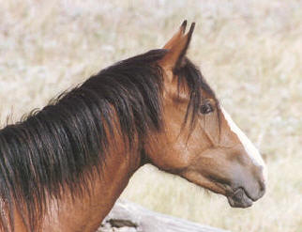

The Registration Process:

Registration is available for Nokotas® if one or both parents are in the Nokota® Horse breed registry. Non-Nokota® parents will be listed as “Other”. In order to qualify for registration, a horse with a non-Nokota® parent will be registered as NPPB and must be at least 25% foundation.
Important notices: The Nokota Horse Conservancy® is committed to responsible breeding practices. As of June 2023, horses whose inbreeding coefficient exceeds 12.5% will no longer be eligible for registration.
Breeders standing stallions must test for and divulge the results of the test for the Lethal White Overo gene. Stallion reports should be accompanied by the results of the LWO test.

Registration Papers:
Registration Papers are issued upon request for a fee of $50.00 at any point after a “Foal Report” has been recorded. To request registration papers the following are necessary:
- Proof of ownership. If you are the breeder this is achieved through the filing of the Foal Report. If you have purchased your horse the proof of ownership can come through a bill of sale or submission of a Registration Paper with the transfer information on the back filled out. If your horse as the Z+ brand you will also need a brand release from the State of North Dakota.

- Pictures must be provided. There should be a picture of each side, taken from a ninety-degree angle and with all four legs showing, and one picture of the head taken from directly in front, with the forelock pulled out of the way to show markings and swirls.

Please note that papers will not be issued until adequate photographs are provided. You will be contacted if additional photographs are required.

- A scan or physical copy of the Registration Request Form (valid for both formal papers and foal reports). Scans can be emailed to Nokota.Registry@gmail.com. Hard copies can be mailed to:

Shawna Lichtenwalner, Breed Registrar
The Nokota Horse Conservancy®
428 Timber Ridge Road
Bluff City, TN 37618
USA

Owner Transfers:
Transfers of ownership can be accomplished with a $20 transfer fee. Requests for transfer of ownership must be accompanied by the signed registration paper. Mail owner transfer requests to:
Shawna Lichtenwalner, Breed Registrar
The Nokota Horse Conservancy®
428 Timber Ridge Road
Bluff City, TN 37618
USA

Re-issuance of Papers:
If papers have been lost, you may request new copies for a $20 fee. Reissued papers can only be granted to the owner listed in the database. Photos of the horse must be provided. To request a new copy of your papers email Nokota.Registry@gmail.com.

Change of Name:
Name change requests can be granted for a $25 fee. The original paper must be mailed to the Nokota Horse Conservancy® along with the Name Change Request Form.

Color Changes:
Given that in the Nokota® breed there is a predominance of colors, such as roans and greys, which are not evident at the time of birth, an owner may request updated papers if a horse changes colors as it matures. Owners have the option of emailing the registry at Nokota.Registry@gmail.com to request an update in the database, or of requesting a re-issue of the horse’s paper with updated color information for a $5 fee. Another way to handle this would be to file the foal report at the time of birth and wait until the horse is a yearling to request formal paper, by which time roaning would be apparent (but not necessarily greying).

Stallion Reports:
Breeders need to submit a Stallion Report that records all mares covered by that stud on a yearly basis. Reports are due by December 31. Breeders must test for the LWO gene and include that information on the stallion report. Stallion reports can be filed on the following fee schedule:
1-20 mares $10
20+ mares $20
Late Fee (after December 31 of the year in question): $25

Payment:
Payment for registration services can be made online through our webpage at www.nokotahorse.org or by mailing a check to the Nokota Horse Conservancy®.
If you have any questions please feel free to contact the registrar, Shawna Lichtenwalner, by email at Nokota.Registry@gmail.com

